BREAKFAST CHATTER
Weekly Bulletin of Rotary Club of Kathmandu Mid-Town
District 3290 Volume No. 15/24 for #766 January 07, 2005
www.rotarymidtown.org.np
JANUARY IS ROTARY AWARENESS MONTH
SUNSHINE ANNOUNCEMENT FOR THE WEEK OF 07 JANUARY, 2005;
Congratulations to Durga, Spouse of Monir on the 10th and far far away to Giannina Spouse of recently transmigrated Rtn Robert (wire transfer of Sunshine Funds appreciated).
*********** MEETING ACTIVITIES:
DATE | ACTIVITY | SUBJECT
7 JAN | Subarna Joshi | Community Participation in Local Area Development
14 JAN | ADRA | Youth Reproductive Health Education Project (ABC)

**************** NEWS: Jyotsna suggested a night at the movies – this coming Sunday the 9th at the newly renovated Kumari Hall, just behind the Russian Cultural Centre. 6 PM sharp. *** On 11 January (Tuesday) in the "Nepal Chamber" school, half way between Naubise and Tistung pass there will be a pure gynaecological camp, requested by the mothers of the girl-children with whom we have our "Girl-Child-Education" projects. The agency in charge of the camp is ADRA, our partner in the centennial Project: Youth Reproductive Health Education (Kavre and Makhwanpur). Hartmut reports that some of our Rotarians have expressed their interest as well our Rotaracters. He will take 3 additional gyn. doctors in his car, as well as Rotaracts and material. Those willing to come should organize their own transport. Departure KTM sharp at 7 am and return by late afternoon.
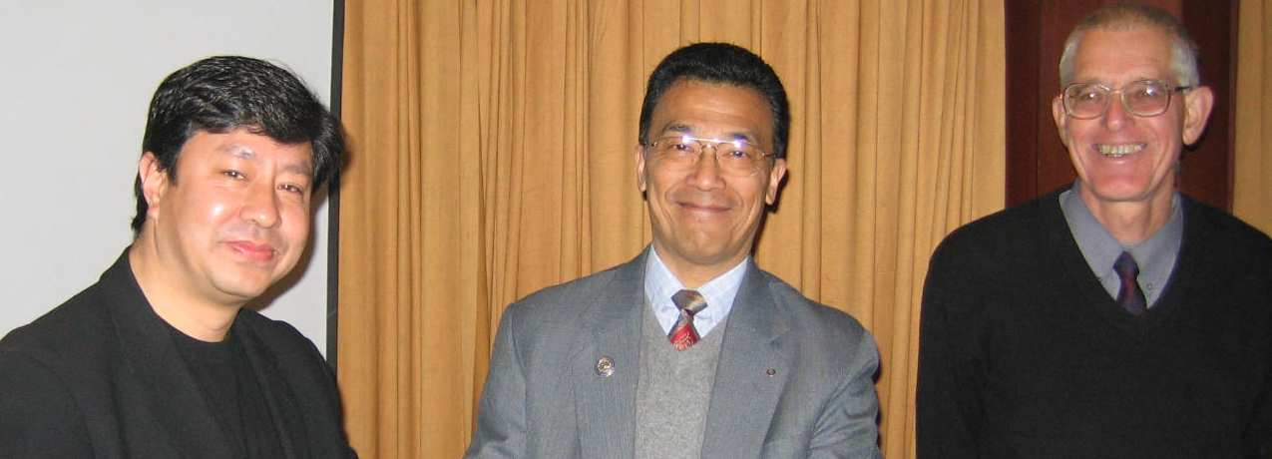
Those willing could organize tea, biscuits, lunch, water, etc. ****************
<<<With smiles like these, this has to be a Happy New Year.

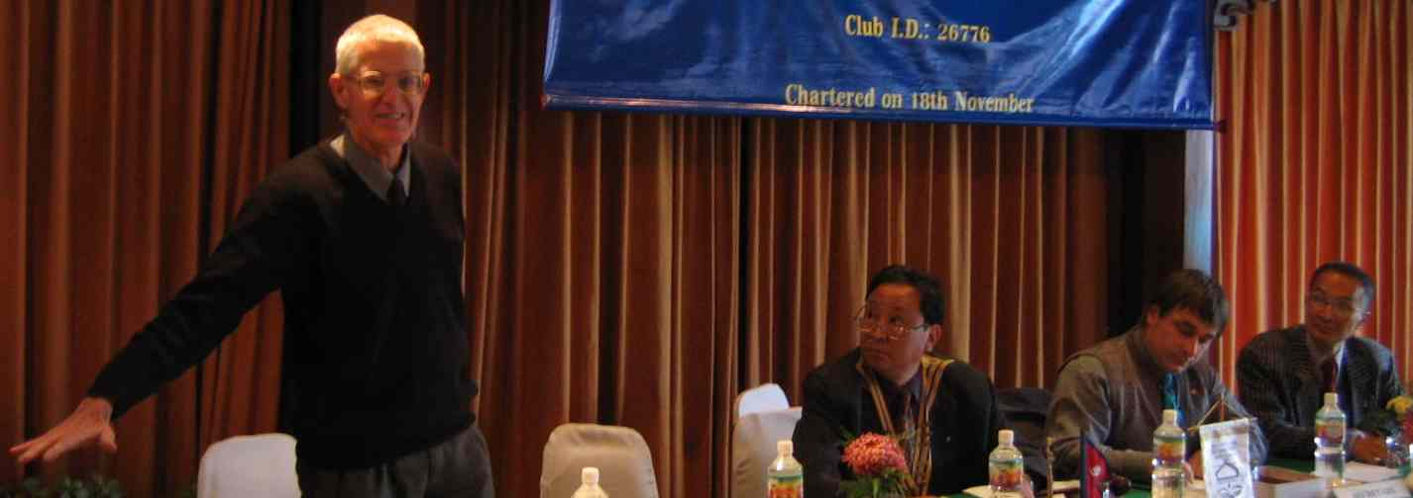

<<<Fr. Robins asks that we make all men our ‘Afno Manche’

Our own SUBARNA JOSHI has mentioned how his neighbors organized and improved their neighborhood. It sounds like a a great example which deserves to be ‘scaled’ in many other places. Please join us for some long-awaited inspiration.
**************** YIR…David

